Common quotation ask

Internal working of @Configuration annotation:
- @Configuration marks a class as a source of bean definitions within the application context.
- Internally, Spring registers beans declared within @Configuration classes during context initialization.
- It provides a declarative way to define beans and their dependencies, enhancing maintainability and readability.
- @Configuration classes are processed by Spring's container at startup, generating bean definitions and wiring dependencies.
- Spring internally caches and manages configurations annotated with @Configuration, optimizing performance and resource utilization.

Internal working of @Service annotation:
- @Service is a specialization of the @Component annotation, indicating that a class serves as a service component.
- Internally, Spring treats classes annotated with @Service similarly to @Component, facilitating component scanning and bean management.
- It enhances code organization and readability by explicitly marking classes as service components.
- @Service annotations enable the use of stereotypes, allowing Spring to apply specific behaviors and optimizations for service components.
- Spring internally registers @Service beans within the application context, making them available for dependency injection and other Spring features.

Internal working of @Component and @ComponentScan: annotation:

@Component:
- Purpose: Marks a class as a Spring-managed bean.
- Functionality: When you annotate a class with @Component, Spring automatically detects and registers it as a bean, making it available for dependency injection in other parts of the application.
- Usage: Used on individual classes to define them as components.

@ComponentScan:
- Purpose: Tells Spring where to search for classes annotated with @Component (or related annotations like @Service, @Repository, @Controller) and register them as beans in the Spring context.
- Functionality: It defines the base packages that Spring should scan to find classes annotated with @Component (and its subtypes).
- Usage: Used on configuration classes to specify which packages should be scanned for Spring beans.

What is a bean in Java?:
- In Java, a bean is a reusable software component that conforms to specific conventions, typically representing application data or functionality.
- Beans are Java objects managed by a container, such as Spring's IoC container, and are typically configured and assembled at runtime.
- Beans are often POJOs (Plain Old Java Objects) annotated with Spring annotations like @Component, @Service, or @Repository.
- Beans can represent various types of components, including domain objects, data access objects, services, and controllers.
- Spring beans are singleton by default, but their scope can be customized to match different application requirements.

Bean Scopes in Spring
- Singleton (@Scope("singleton"))
  - Description: This is the default scope. A single instance of the bean is created and shared across the entire Spring container. All requests for this bean get the same instance.
  - Usage: Suitable for stateless beans where a single shared instance is sufficient and efficient.
  - Lifecycle: Created once per Spring container lifecycle, initialized at application startup.
- Prototype (@Scope("prototype"))
  - Description: A new instance of the bean is created each time it is requested from the container. The container does not manage the bean's lifecycle beyond its creation.
  - Usage: Ideal for beans where a new instance is required for each use, such as stateful beans or beans that require unique instances.
  - Lifecycle: Created every time it is requested, and not managed beyond creation (e.g., no destruction callback).
- Request (@Scope("request"))
  - Description: A new instance of the bean is created for each HTTP request. The bean is scoped to the lifecycle of a single HTTP request.
  - Usage: Commonly used in web applications where you need a new instance per HTTP request, such as user sessions or request-specific data.
  - Lifecycle: Created and destroyed with each HTTP request.
- Session (@Scope("session"))
  - Description: A new instance of the bean is created for each HTTP session. The bean is scoped to the lifecycle of an HTTP session.
  - Usage: Useful in web applications where you need to maintain state or user-specific data across multiple requests within a single session.
  - Lifecycle: Created and destroyed with each HTTP session.
- Application (@Scope("application"))
  - Description: A single instance of the bean is created and shared across the entire ServletContext. It is similar to the Singleton scope but specific to web applications.
  - Usage: Used when you need a bean to be shared across all users and sessions in a web application.
  - Lifecycle: Created once per ServletContext lifecycle, similar to a singleton but within the web application context.
- WebSocket (@Scope("websocket"))
  - Description: A new instance of the bean is created for each WebSocket session. The bean is scoped to the lifecycle of a WebSocket session.
  - Usage: Suitable for beans that handle WebSocket connections and require instance-specific data.
  - Lifecycle: Created and destroyed with each WebSocket session.

Summary
- Singleton: One instance per Spring container (default).
- Prototype: New instance for each request.
- Request: New instance for each HTTP request (web applications only).
- Session: New instance for each HTTP session (web applications only).
- Application: One instance per ServletContext (web applications only).
- WebSocket: New instance for each WebSocket session (web applications only).

What is @Bean in Java in detail?:
  - @Bean is a method-level annotation used within classes annotated with @Configuration in Spring.
  - It serves as a factory method for creating and configuring beans explicitly.
  - Internally, Spring invokes @Bean methods during application context initialization to instantiate and configure the associated beans.
  - @Bean methods can be parameterized, allowing dependencies to be injected into the created beans.
  - @Bean annotations provide a way to define beans with custom initialization logic, non-default scopes, and other customizations.

What is dependency injection in Java?:
Dependency Injection (DI) is a core concept in modern software development, especially in the context of frameworks like Spring Boot. It's a design pattern that helps you build loosely coupled, flexible, and testable applications.
In simple terms, Dependency Injection means that a class doesn't create its own dependencies (the objects it needs to do its job). Instead, those dependencies are provided to it from the outside.
Dependency Injection is a design pattern where objects receive their dependencies from an external source (like Spring’s IoC container) instead of creating them themselves. It enables loose coupling, better testability, and easier maintenance.

How does a POST request work in microservices architecture?:
• Client sends a POST request:
- The process begins when a client sends a POST request to an endpoint exposed by an API gateway.
• API Gateway routes the request:
- The API gateway receives the incoming POST request and routes it to the appropriate microservice based on the request URL.
• Microservice receives the request:
- The targeted microservice, which is built using Spring Boot, receives the POST request.
• Spring MVC Controller handles the request:
- Within the microservice, the Spring MVC controller maps the incoming POST request to a handler method annotated with @PostMapping or @RequestMapping.
• Request processing in the microservice:
- Spring processes the incoming request data, which may include request parameters, form data, or JSON payloads, based on the method signature of the handler method.
• Service Layer interaction:
- The controller method invokes the appropriate service layer components to perform business logic, data validation, and interaction with databases or other microservices.
- Spring's @Autowired annotation or constructor injection is commonly used to inject service dependencies into the controller.
• Data persistence:
- If required, the service layer interacts with a database, such as MySQL or MongoDB, to store or retrieve data.
• Service discovery with Eureka:
- Before sending the response, the microservice may need to communicate with other microservices. In a microservices architecture utilizing service discovery, the microservice looks up the network location of other microservices using a service registry like Eureka.
• Invoking other microservices:
- If necessary, the microservice may make requests to other microservices to fulfill the business logic of the POST request. This interaction can be synchronous or asynchronous, depending on the requirements.
• Response construction:
- Once the business logic is executed and any necessary interactions with databases or other microservices are completed, the microservice constructs an HTTP response.
- Spring uses @ResponseBody to serialize the response data into JSON or another format suitable for the client.
• Response sent to the client:
- The constructed response is sent back to the client through the API gateway, which forwards the response to the original requester.

Difference between @ResponseBody and @RequestMapping:
  - @ResponseBody is an annotation used to indicate that the return value of a method should be bound to the web response body in Spring MVC.
  - @RequestMapping is used to map HTTP requests to handler methods in Spring MVC controllers, specifying the URL path and HTTP method.
  - While @ResponseBody specifies the content of the response body, @RequestMapping defines the mapping of requests to handler methods.
  - @ResponseBody is typically used in conjunction with @RequestMapping or @GetMapping, @PostMapping, etc., to produce the response body.
  - @RequestMapping can be applied at the method or class level to define request mappings for multiple methods within a controller.

What is the Spring context?

The Spring Context, or ApplicationContext, is the central component of the Spring Framework. It's the IoC (Inversion of Control) container that's responsible for managing the entire lifecycle of your application's objects, also known as beans.
- The Spring context is the core of the Spring Framework, providing the runtime environment for managing application components and their dependencies.
- It represents the application context or container that initializes, configures, and manages beans throughout the application lifecycle.
- The Spring context loads bean definitions, resolves bean dependencies, and applies configuration settings specified in XML files, Java configuration classes, or annotations.
- Spring contexts can be hierarchical, allowing for the creation of parent and child contexts to organize and modularize application components.
- The Spring context provides various services such as dependency injection, internationalization, event propagation, and resource loading to facilitate application development.

What is ioc container
In simple terms, an IoC (Inversion of Control) container is a framework that manages the creation and lifecycle of objects in an application. Instead of the programmer manually creating and managing object dependencies, the IoC container takes care of injecting dependencies automatically.

How it works:
- IoC container creates objects (also called beans in Spring).
- It injects the necessary dependencies into these objects, ensuring they have everything they need to function.
- This approach makes the application more modular, easier to test, and maintain.

Example:
Imagine you have a Car object that needs a Engine to work. With IoC, you don't need to create the Engine inside the Car class. The IoC container will create both the Car and Engine and automatically connect them.

Key Benefits:
- Decoupling: Objects are not tightly coupled, making them easier to manage.
- Simplified code: You don’t have to write code to manage object creation and dependencies.
In Spring, the IoC container is at the heart of the framework and is typically referred to as the Spring Container. It uses dependency injection to wire beans together.

How IoC Works in Spring Boot
When a Spring Boot application starts, the IoC container is created. The container then scans the application's classpath for components, configurations, and beans, which it then manages. Here's how IoC is typically used in a Spring Boot application:

Example Implementation
- Define Components and Beans
  - Component: Classes annotated with @Component, @Service, @Repository, or @Controller are automatically detected by the IoC container.
  - Bean: Methods annotated with @Bean in a configuration class are used to define beans.
- Configure Application Context
Spring Boot automatically configures the application context based on the classpath contents and annotations used.

Spring security annotation
Spring Security provides several annotations that you can use to secure your Spring-based applications. These annotations help in applying security rules to methods and endpoints. Here are some of the key Spring Security annotations:
- @Secured: // Method accessible only to users with ROLE_USER authority
  - @Secured is a method-level security annotation used to specify which roles are allowed to access a method.
  - You can annotate a method with @Secured("ROLE_USER") to ensure that only users with the "ROLE_USER" authority can invoke that method.
  - It requires method security to be enabled in the Spring Security configuration.
- @PreAuthorize // Method accessible only to users with ROLE_ADMIN authority
- and @PostAuthorize: // Method returns an object, and only objects created by the current user are allowed
  - @PreAuthorize and @PostAuthorize are method-level security annotations that allow you to specify complex security expressions using SpEL (Spring Expression Language).
  - @PreAuthorize is evaluated before the method invocation to determine whether the user is allowed to access the method.
  - @PostAuthorize is evaluated after the method invocation to filter the results based on the specified security expression.
  - These annotations provide more flexibility compared to @Secured.
- @RolesAllowed: // Method accessible only to users with ROLE_ADMIN authority
  - @RolesAllowed is similar to @Secured, but it's a standard Java EE annotation.
  - You can use @RolesAllowed("ROLE_ADMIN") to restrict access to a method to users with the "ROLE_ADMIN" authority.
  - Spring Security provides support for @RolesAllowed through its integration with Java EE security annotations.
- @PreFilter // Filters the list of objects based on the owner field
- and @PostFilter: // Retrieves a list of objects and filters based on the owner field
  - @PreFilter and @PostFilter are annotations used for method-level security filtering.
  - @PreFilter allows you to filter method parameters before the method invocation based on a specified security expression.
  - @PostFilter filters the return value of a method after the method invocation based on a specified security expression.
- @Secured, @PreAuthorize, @PostAuthorize, @PreFilter, and @PostFilter:
  - These annotations provide powerful tools for securing methods and endpoints in Spring applications.
  - They allow you to express fine-grained security rules using SpEL expressions and annotations.
  - By combining these annotations, you can implement complex security requirements with ease.
These annotations offer a declarative way to define security rules in your Spring applications, making it easier to manage and maintain security configurations. You can use them to secure your controllers, services, and other components effectively.

1• Internal working of Spring Boot application annotation:
- Spring Boot annotations encapsulate common configurations and behaviors, reducing boilerplate code.
- Annotations trigger various actions during the application lifecycle, such as component scanning, auto-configuration, and bean registration.
- Annotations like @SpringBootApplication combine multiple annotations, enabling cohesive setup and initialization.
- Internal working of @Autowired annotation:
- @Autowired is part of Spring's dependency injection mechanism, facilitating the wiring of beans.
- Internally, Spring searches for candidate beans matching the type of the annotated field, constructor, or method parameter.
- It resolves dependencies based on the type, ensuring type safety and reducing manual configuration.
- @Autowired can be applied at the field, constructor, setter method, or parameter level, offering flexibility in injection points.
- Spring internally uses reflection and proxies to inject dependencies, decoupling components and promoting modularity.

Implement security spring boot application

Implementing Spring Security in a Spring Boot application involves several steps. Here's a guide to help you get started:
- Add Spring Security Dependency:
  - Add the Spring Security dependency to your pom.xml (for Maven) or build.gradle (for Gradle) file.

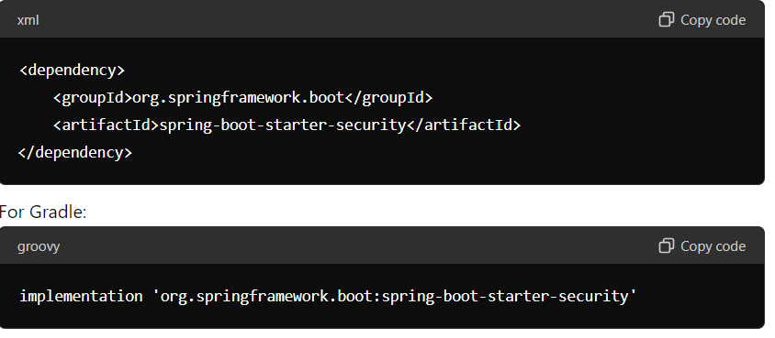
Configure Spring Security:
- Create a configuration class to customize Spring Security settings.
- You can extend WebSecurityConfigurerAdapter to configure security settings.
- Override the configure(HttpSecurity http) method to define security rules.
- Example: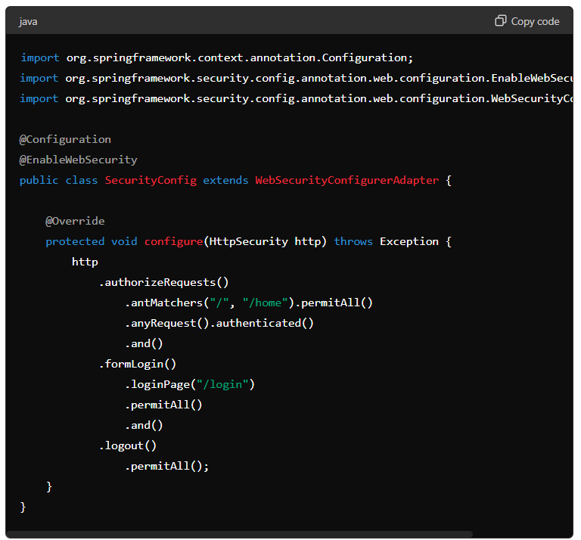
Create UserDetailsService:
- Implement a UserDetailsService to load user details from a data source.

- 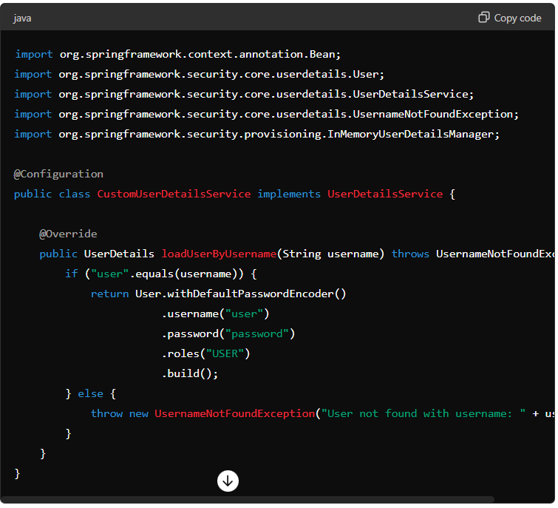
Secure Endpoints:
- Secure endpoints based on roles or specific authentication requirements.
- Use annotations such as @Secured, @PreAuthorize, or @RolesAllowed to secure methods or controllers.
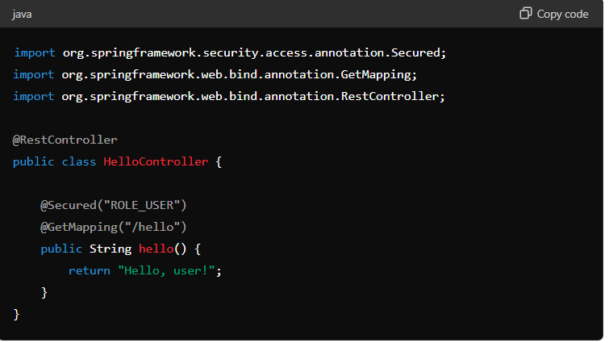
Testing:
- Test your application to ensure that security configurations are working as expected.
- Verify that unauthorized access to protected endpoints is restricted.
- Test authentication and authorization with different user roles.

Authentication and authorization
Authentication and authorization are two fundamental concepts in security, particularly in the context of software applications. Here's a breakdown of each concept:
- Authentication:
  - Authentication is the process of verifying the identity of a user or system.
  - It ensures that the entity claiming to be a particular user or system is indeed that entity.
  - Authentication mechanisms include:
    - Username and password authentication: Users provide their credentials (username and password) to prove their identity.
    - Token-based authentication: Users present a token (e.g., JWT) generated after successful login to authenticate subsequent requests.
    - Certificate-based authentication: Users present a digital certificate issued by a trusted authority to authenticate themselves.
  - In Java, authentication is often implemented using frameworks like Spring Security, which provides authentication providers, filters, and mechanisms to authenticate users based on various methods.
- Authorization:
  - Authorization is the process of determining whether an authenticated user or system has the necessary permissions to access a particular resource or perform a specific action.
  - It ensures that users can only access resources and perform actions that they are authorized to access or perform.
  - Authorization mechanisms include:
    - Role-based access control (RBAC): Users are assigned roles, and access to resources is based on the roles assigned to them.
    - Attribute-based access control (ABAC): Access decisions are based on attributes of the user, resource, and environment.
    - Rule-based access control: Access decisions are determined by rules defined by administrators or policies.
  - In Java, authorization is often implemented in conjunction with authentication using frameworks like Spring Security, which provides mechanisms to define access control rules, roles, and permissions.

Exception Handel in spring boot application

Implementing exception handling in a Spring Boot application involves configuring global exception handling to manage exceptions gracefully. Here's a guide on how to do it:
- Create Custom Exception Classes:
  - Define custom exception classes that extend RuntimeException or its subclasses to represent specific types of errors in your application.

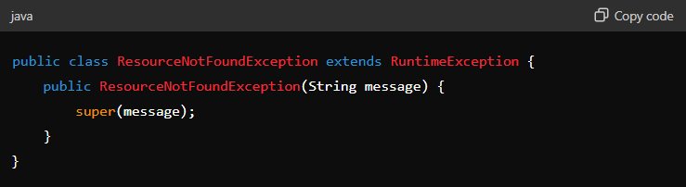

Define Exception Handler:
- Create a global exception handler class annotated with @ControllerAdvice to handle exceptions thrown by controllers.
- Annotate methods within this class with @ExceptionHandler to handle specific types of exceptions.
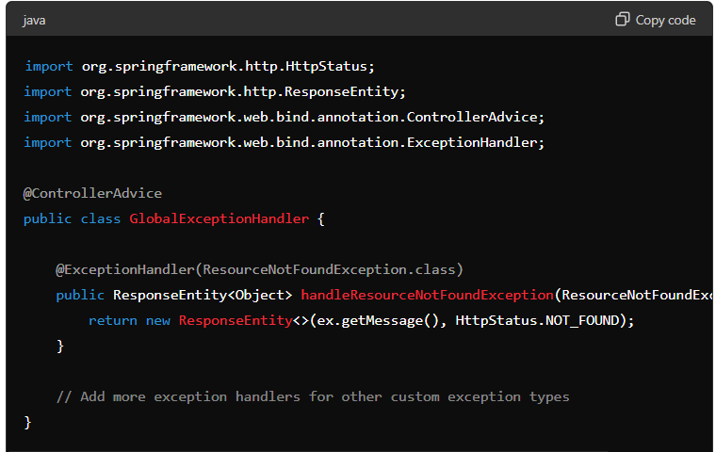
Throw Custom Exceptions:
- Within your controller or service classes, throw custom exceptions when specific error conditions occur.
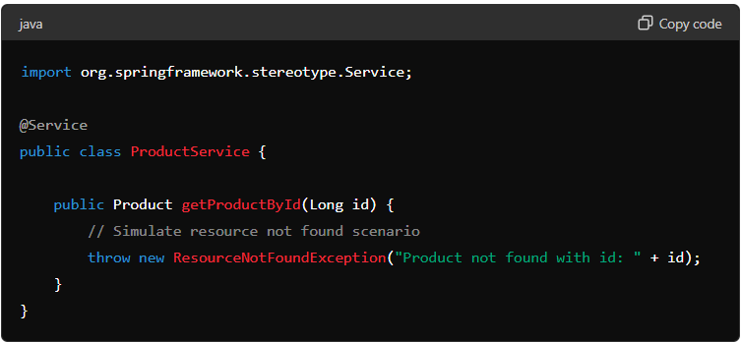

Configure Default Exception Handling (Optional):
- If needed, configure default exception handling to catch any unhandled exceptions and provide a generic error response.

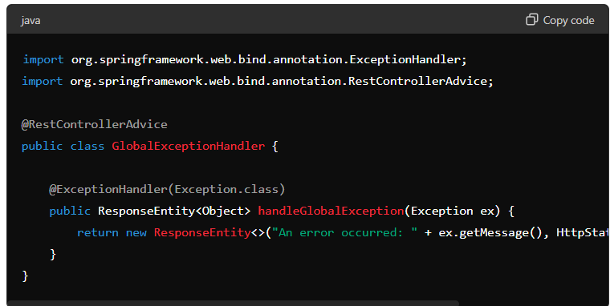

Test Exception Handling:
- Write unit tests to verify that exceptions are handled as expected.
- Mock service calls or controller invocations that may throw exceptions and assert the response status and content.

Exception Handel in Anotation
@ControllerAdvice:
  - Used to define global exception handling for all controllers.
- @ExceptionHandler:
  - Used within a @ControllerAdvice class to handle specific types of exceptions.
- @ResponseStatus:
  - Annotates a custom exception class to specify the HTTP status code to be returned when the exception is thrown.
- @RestControllerAdvice:
  - Similar to @ControllerAdvice, but specifically used for handling exceptions in RESTful controllers.
These annotations provide a convenient way to manage and handle exceptions in your Spring Boot applications, allowing for centralized error handling and consistent responses to clients.

Transactions
- transactions are used to ensure the atomicity, consistency, isolation, and durability (ACID) properties of a group of database operations
- Transactions are a way to group multiple database operations together as a single unit of work.
- Transactions ensure that either all operations within the transaction are successfully completed or none of them are applied.
- Transactions can be implemented in Java using the JDBC API, JPA, or frameworks like Spring and Hibernate.
- Transactions are important for ensuring data integrity, consistency, and reliability when working with databases.
- Here are some of the benefits of using transactions in Java:
- Data integrity: Transactions ensure that data is not corrupted or lost in case of an error.
- Consistency: Transactions ensure that the database is always in a consistent state.
- Reliability: Transactions ensure that database operations are performed reliably, even in the event of an error.
- Performance: Transactions can improve performance by grouping multiple database operations together.

Summary
- Dependencies: Add Spring Data JPA and database dependencies.
- Configuration: Set up database connection properties.
- Enable Transactions: Use @EnableTransactionManagement.
- Transactional Methods: Annotate methods with @Transactional.

What is jpa repository

A JPA Repository is an interface in Spring Data JPA that provides methods for interacting with a database using Java Persistence API (JPA). It simplifies database operations like CRUD (Create, Read, Update, Delete) without requiring you to write SQL queries or boilerplate code.

Key Features:
- Pre-built methods: It comes with many common methods for database operations, such as save(), findById(), delete(), and more.
- Custom queries: You can define your own query methods based on method naming conventions or using JPQL (Java Persistence Query Language).
- Pagination and Sorting: Supports pagination and sorting out of the box.

How it works:
- You define a repository interface that extends JpaRepository, and Spring Data JPA automatically provides the implementation for it at runtime.

What is saga pattern in microservices
The Saga Pattern in microservices is used to maintain data consistency across multiple services by breaking a transaction into smaller, independent steps. Each microservice performs a local transaction, and if one fails, compensation (undo) actions are triggered to rollback previous steps.
There are two main types:
• Choreography:
- Each service performs its local transaction and emits an event to trigger the next service in the sequence.
- If a failure occurs, services that completed their tasks emit compensating events to undo their operations.
- There’s no central controller; services interact through events.
• Orchestration:
- A central orchestrator controls the entire saga, directing each service to perform its local transaction.
- If a failure happens, the orchestrator instructs the relevant services to execute compensation logic.
- The orchestrator manages the flow of transactions and rollbacks.

. Choreography Example (Event-Driven):
Let's say we have an Order Processing System with three microservices:
- Order Service: Places the order.
- Payment Service: Processes the payment.
- Inventory Service: Updates the inventory.

Process:
- Order Service places an order and emits an event OrderPlaced.
- Payment Service listens to OrderPlaced and processes the payment. If successful, it emits PaymentCompleted.
- Inventory Service listens to PaymentCompleted and updates the inventory.
If one step fails, compensating actions (like rolling back the order or refunding the payment) are triggered by emitting failure events.

Flow:
- Order Service → Emit OrderPlaced event.
- Payment Service listens to OrderPlaced → Processes payment → Emits PaymentCompleted.
- Inventory Service listens to PaymentCompleted → Updates inventory.
There’s no central controller. Each service listens for relevant events and acts accordingly.

2. Orchestration Example:
In the same Order Processing System, now a central Orchestrator Service controls the workflow.

Process:
- Order Service tells the Orchestrator that an order has been placed.
- The Orchestrator directs the Payment Service to process the payment.
- Once payment is successful, the Orchestrator directs the Inventory Service to update the inventory.
If any service fails, the Orchestrator triggers rollback steps (e.g., cancel the payment or revert the inventory update).

Flow:
- Order Service → Notifies Orchestrator of OrderPlaced.
- Orchestrator → Calls Payment Service to process payment.
- Orchestrator → Calls Inventory Service to update inventory after payment success.
In this case, the Orchestrator centrally controls each step of the process.

Circuit break in microservices
The Circuit Breaker pattern is used in microservices to prevent cascading failures and ensure system stability when a service fails or is too slow to respond.

Key Concept:
- It acts like an electrical circuit breaker: when a service starts failing (due to being down or overloaded), the circuit "opens," preventing further calls to the failing service.
- This helps avoid unnecessary requests to a failing service, protecting the rest of the system.

States of a Circuit Breaker:
- Closed:
  - The system operates normally, and requests are allowed to flow to the service.
- Open:
  - After a certain number of failures, the circuit opens, and all further requests to the service are blocked, preventing more failures.
- Half-Open:
  - After a cooldown period, a limited number of requests are allowed to check if the service has recovered.
  - If successful, the circuit closes; if not, it re-opens.

Benefits:
- Prevents system overload.
- Improves resilience by quickly failing over when services are down.
This pattern is often used in conjunction with retry mechanisms and fallbacks.

advantages with spring boot?

• Auto-Configuration – Reduces boilerplate setup by automatically configuring beans based on dependencies.
• Embedded Servers – Runs on embedded Tomcat, Jetty, or Undertow → no need for external server deployment.
• Production-Ready Features – Actuator provides health checks, metrics, logging, and monitoring out of the box.
• Microservices Friendly – Easy to create cloud-native, microservice architectures with minimal config.
• Convention over Configuration – Opinionated defaults let you start quickly while still allowing customization.
• Easy Dependency Management – spring-boot-starter POMs simplify Maven/Gradle dependency setup.
• Rapid Development – Spring Initializr, devtools (auto restart, hot reload) speed up development.
• Cloud & Container Support – Built-in support for Docker, Kubernetes, and cloud platforms.
• Security Integration – Works seamlessly with Spring Security for authentication & authorization.
• Wide Ecosystem – Integrates easily with JPA/Hibernate, Kafka, RabbitMQ, Redis, NoSQL, REST, GraphQL, etc.

how to make jetty as default container?
we need to add the dependency of the jetty and we need to do modification in the application.properties and pom.xml

what is ioc in spring boot?
IoC (Inversion of Control) in Spring Boot:
It’s a principle where the Spring IoC container manages the creation and lifecycle of objects (beans) instead of the developer.
- Objects are created, wired, and injected automatically.
- Done via annotations like @Component, @Service, @Repository, @Autowired.
- Advantage → Loose coupling, easier testing, faster development.

what is the difference btw component and service(metadata)?
- Purpose:
  - @Component → Generic bean (any type of class).
  - @Service → Specifically marks business logic layer beans.
- Semantic Meaning:
  - @Component → No special intent, just a Spring-managed class.
  - @Service → Tells developers/tools “this is a service” (business logic).
- Tooling / AOP Support:
  - @Component → Treated as a plain bean.
  - @Service → Can get extra behaviors (e.g., transaction management, service-specific AOP).
👉 Summary: Both register beans, but @Service adds semantic clarity + potential AOP features.

how to connect with multiple database?
In Spring Boot, we configure multiple databases by defining separate DataSource, EntityManagerFactory, and TransactionManager beans for each database.
- In application.yml, we declare multiple datasource properties (e.g., MySQL, PostgreSQL).
- Then, we create two configuration classes, each annotated with @EnableJpaRepositories, pointing to different entity and repository packages.
- Each config class binds to its own datasource, entity manager, and transaction manager.
- Finally, we keep entities and repositories in separate packages so that Spring knows which database to use.
This way, the application can run queries on multiple databases simultaneously, ensuring proper transaction management for each.

how to manage transcation in springboot?
In Spring Boot, we manage transactions mainly with the @Transactional annotation, which makes methods atomic (all-or-nothing). Spring provides rollback on runtime exceptions by default, and we can customize behavior with propagation, isolation, and rollback rules. For advanced cases, we can use programmatic transaction management via TransactionTemplate or manage multiple datasources with separate transaction managers

What is store procedure ?

How to call store procedure ?

How do you write queries and dynamic queries in Spring Boot?
Answer:
In Spring Boot with JPA, we have multiple ways to write queries:
- Derived Queries – Spring generates SQL from method names.
  - Example: findByName(String name)
  - ✅ Simple, no SQL needed.
- JPQL Queries (@Query) – Write queries using entity fields, database independent.
  - Example: @Query("SELECT u FROM User u WHERE u.age > :age")
- Native Queries (@Query(nativeQuery = true)) – Raw SQL executed on the database.
  - Example: @Query(value = "SELECT * FROM users WHERE name = :name", nativeQuery = true)
- Dynamic Queries – When filter conditions are optional or complex:
  - Conditional JPQL: Skip filters if params are null.
  - CriteriaBuilder: Build queries programmatically at runtime.
  - Specification: Cleaner, reusable dynamic queries for complex conditions.

What are Spring Boot Profiles?
Spring Boot Profiles allow you to define multiple environment-specific configurations and load them dynamically. You can activate a profile via properties, command line, or environment variable, and even create beans that only load for a specific profile using @Profile.

what is the main difference btw properties file and yml

properties is flat key-value format; .yml is hierarchical and more readable for complex configurations. Both are supported by Spring Boot, but YAML is preferred for nested configs and lists.

why YAML is often preferred over properties in modern Spring Boot apps?

YAML is preferred because it’s more readable, supports nested structures, lists, maps, and profile-specific blocks in a cleaner way than properties files.

what is apigateway?
An API Gateway is a single entry point for client requests in a microservices architecture, responsible for routing, security, load balancing, and handling cross-cutting concerns.

how to secure microservices?
Secure microservices by enforcing authentication and authorization (JWT/OAuth2), securing service-to-service communication (HTTPS/mTLS), and centralizing security at the API Gateway. Follow best practices like rate-limiting, secrets management, and role-based access control.

